* Connection is valid only for organisational, office or school accounts who have MS SHAREPOINT access.

**Step-1**

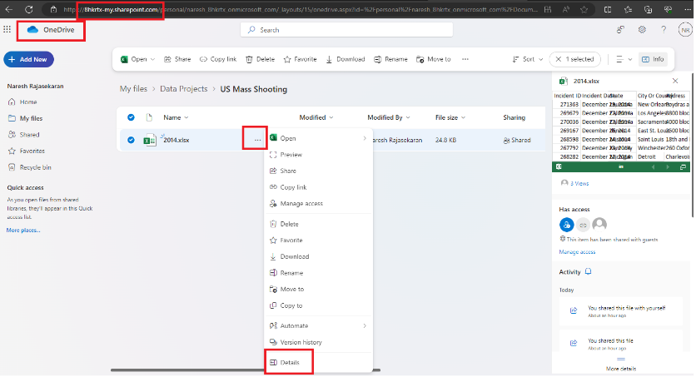

**Step-2**

Copy the path

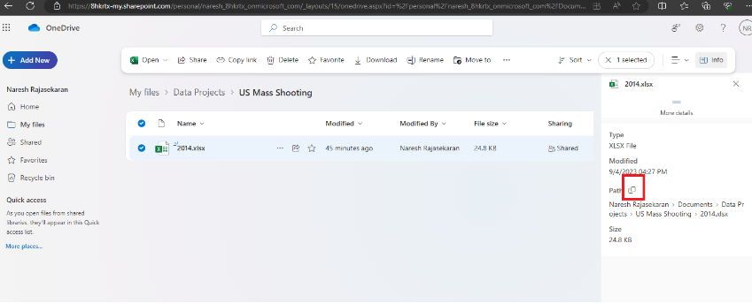

**Step-3**

Open the “Web” Data Source

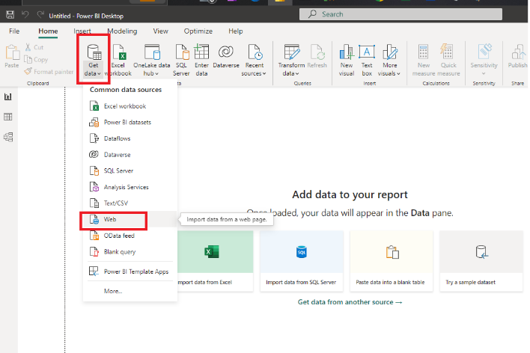

**Step-4**

Paste the copied path and click OK

**Step-5**

Sign-in to organisational account

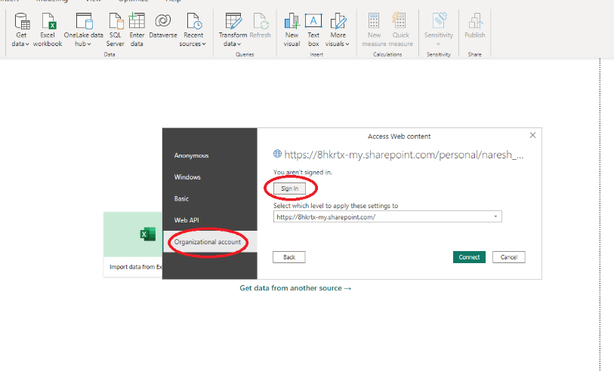

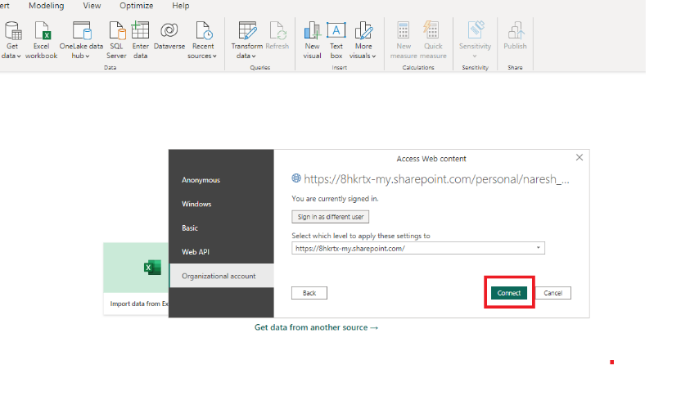

**Step-7**

Load the Datasource into PowerBI

